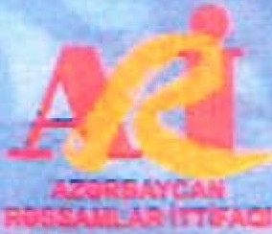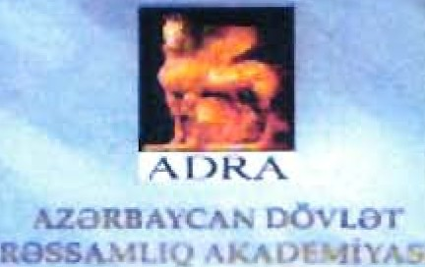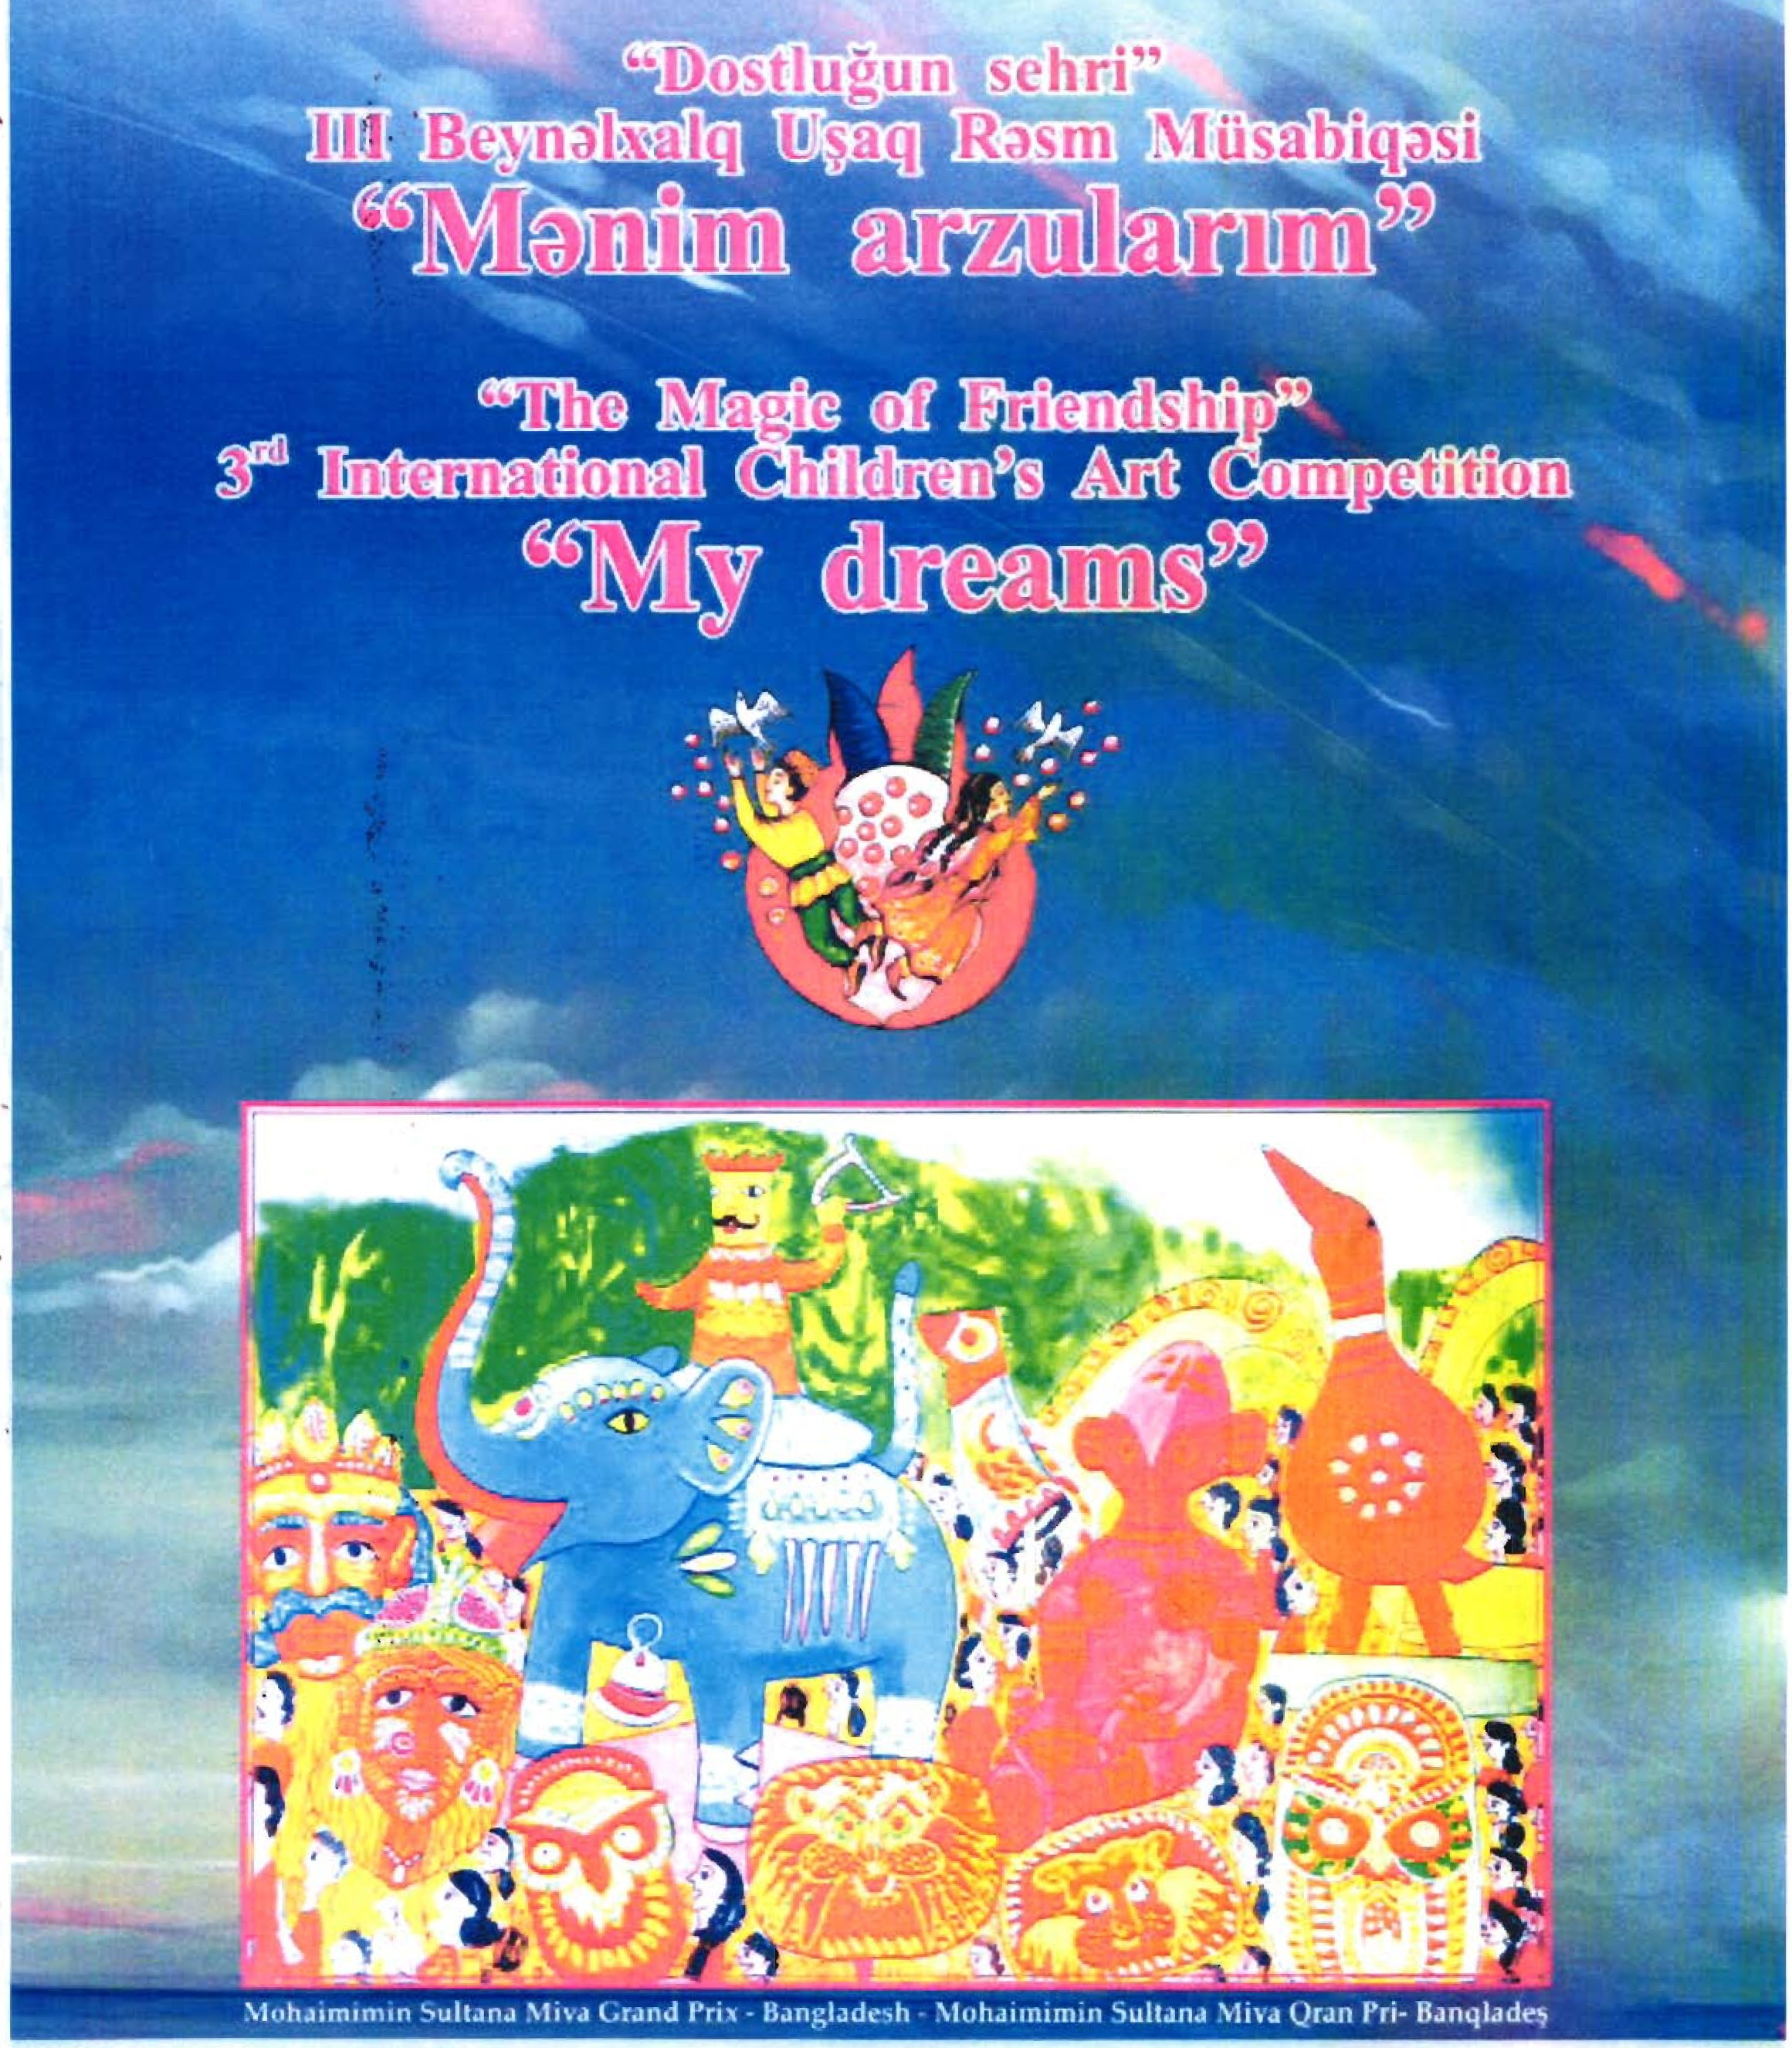
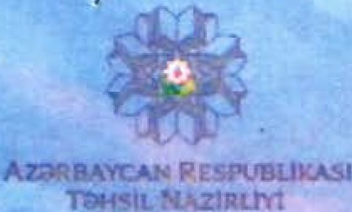

1· r .,.
t'. . •
8
,.

3rd INTERNATIONAL CHILDREN'S ART COMPETITION
"THE MAGIC OF FRIENDSHIP"

Baku, Azerbaijan 2018

THE NAME OF COMPETITION:
3rd Children's International Art Competition "The Magic of Friendship" will be held with the slogan "My dreams"
Sharpen your color pencils!
Brush up your art skills!
Take part at the 3rct International Children's Art Competition! Draw, Color and create an "OUT OF THE WORLD" masterpiece! Let's travel through dreams together!

ORGANIZERS:
- Ministry OF Education of the Republic of Azerbaijan
-Children's Development Center #3

PARTNERS:
- Union of Azerbaijan Artists
- Azerbaijan State Academy of Arts

AIMS OF THE COMPETITION:
- to get to know children's dreams and wishes
- to expand children's horizon and fantasies
-to discover children's ideas and thoughts
- to create mutual respect and friendship between children of the world
-to reveal young talents

PARTICIPANTS OF THE COMPETITION:
Children aged 6 to 15 can participate in the competition

THE WORKS WILL BE EVALUATED IN THREE AGE GROUPS:
- 6 to 8 years
- 9 to 12 years
- 13 to 15 years

FORMAT AND TECHNIQUE:
- Any technique is allowed (painting, graphics, collage etc.)
- The size of work should not exceed 60x40
-Each participant can submit only one painting for the competition
- 10-15 paintings are accepted from each institution

- Works should not be framed
-Information of the participant must be filled in block letter according to the etiquette and attached to the back side of the painting
- Paintings that do not meet the requirements of the competition are not accepted
- The works submitted for the competition will not be returned to their authors

DEADLINES:
Dispatch of invitations to the countries-participants: May, 2018
Submission of the work: October 15,2018
Evaluation of the works: November 15, 2018
The summary of the competition and ceremonial opening of the post-competition exhibition with the participation of representatives of the embassies of the participating countries: December, 2018

AWARDS:
The evaluation of works will be made by the jury approved by the Organizing Committee. The winners and prize-winners in each age category will be awarded with I, II, III degree medals and diplomas according to each age category. Catalog and award documents will be sent to the winners.

NAME, PATRONYMİC NAME, SURNAME
AGE
GENDER
TITLE OF THE ENTRY
NAME OF THE SCHOOL
ADRESS OF THE SCHOOL
POST CODE
CİTY
COUNTRY
EMAİL ADRESS OF THE SCHOOL

