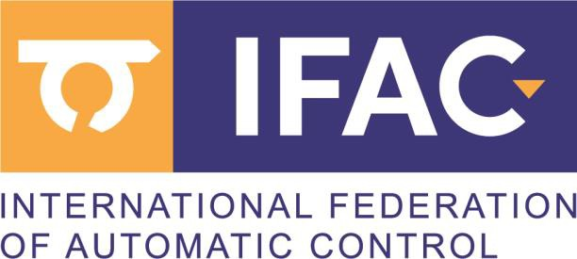SECOND CALL FOR PAPERS
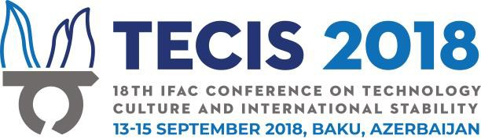
Organizers:
Azerbaijan Robotics and Automation Society (ARAS) Vienna University of Technology, IHRT
Partners:
Ministry of Education of Azerbaijan Republic
Azerbaijan National Academy of Sciences Ministry of Transport, Communication and High Technologies of the Azerbaijan Republic
Sponsors:
International Federation of Automatic Control (IFAC) IFAC TC 9.5 Technology, Culture and International Stability
Technical Co-sponsors:
IFAC TC 4.2. Mechatronic Systems
IFAC TC 4.3. Robotics IFAC TC 5.2 Manufacturing Modelling for Management and Control
IFAC TC 7.5. Intelligent Autonomous Vehicles
IFAC TC 9.1. Economic, Business, and Financial Systems
IFAC TC 9.2 Social Impact of Automation
Federation of European Simulation Societies – EUROSIM

International Program Committee:
Abbas Alili, (AZE) Jorge Bauer, (ARG) Dietrich Brandt, (GER) Felix Breitenecker, (AUT) Nicolae Bulz, (ROM) Peter Carew, (IRE) Long Chen, (MACAO) Zheng Cheng, (PRC) Ian Craig, (RSA) Maya Dimitrova, (BUL) A. Talha Dinibutun, (TUR) Alexandre Dolgui, (FRA) Mary Doyle Kent, (IRE) Ion Dumitrache, (ROM) Numan DURAKBASA, (AUT) Karamjit Gill, (UK) Peter Groumpos, (GRE) Chingiz Hajiyev, (TUR) Fuad Hajiyev, (AZE) Edmond Hajrizi, (KOS) M. Hersh, (SCO) Gheorghi Dimirovski, (MAC)/(TUR) Luis Camarinha-Matos, (POR) Navazi Ismayilov (AZE) Naila Valiyeva (AZE) Nargiz Safarova (AZE)

NOC Chair - Bahadur Ibrahimov, AZERBAIJAN Norbert Jesse, GERMANY Anita Kealy, IRELAND Bernd Kopacek, AUSTRIA

IPC Chair - Peter Kopacek, AUSTRIA Francoise Lamnabhi-Lagarrigue, FRANCE Bogdan Lewoc, POLAND
Vatchkov G.Lubenov, BULGARIA/AZERBAIJAN NOC Vice Chair - Manafaddin Namazov, AZERBAIJAN Reza Moheimani, USA Reinhard Neck, AUSTRIA Mariana Netto, FRANCE Sinead O'Neill Somers, IRELAND John Organ, IRELAND Wilfrid Perruguetti, FRANCE Paul Plöger, GERMANY Refik Samet, TURKEY Kozeta Sevrani, ALBANIA Nayden Shivarov, BULGARIA Sarah Spurgeon, UK Amy Stapleton, IRELAND IPC Vice Chair, Industry - Larry Stapleton, IRELAND Tejan Thakar, IRELAND/INDIA Andon Topalov, BULGARIA Janelle Townsend, USA Vladimir Tsyganov, RUSSIA Tibor Vamos, HUNGARY Ljubisa B. Vlacic, AUSTRALIA
National Organization Committee:
Bahadur Ibrahimov (AZE) Aydin Kazimzada (AZE) Ramiz Humbatov (AZE) Rasim Aliguliyev (AZE) Telman Aliyev (AZE) Alexandra Rommens (AUT) Misir Mardanov (AZE) Julia Linert (AUT) Fikrat Aliyev (AZE) Florian Sengstschmid (AUT) Ulkar Sattarova (AZE) Georg Haemmerle (AUT) Elmir Mehdiyev (AZE) Manafaddin Namazov (AZE) Abbas Alili (AZE) Mubariz Goyushlu (AZE)

Honorary Organizing Committee:
Akif Alizadeh (AZE) Mustafa Babanli (AZE) Gulchohra Mammadova (AZE) Elmar Qasimov (AZE) Will be updated upon confirmations…

Editors:
Peter Kopacek (TU Wien/IHRT) Bahadur Ibrahimov (ARAS)

Invitation to TECIS 2018:
It is our pleasure to invite you to participate in the TECIS 2018, which aims to bring together researchers and practitioners from industry and academia to give an overview of the state of the art, to present new research results and to exchange ideas and experiences in the fields of technology and international stability.

Meeting Scope and Objectives:
Technology development leads to dramatic changes in international stability. It has never been so important to examine system stability. Currently and during the recent years social international and national systems of control have been shown to be inadequate and prone to be fundamental and most basic instable. Many basic assumptions are no longer certain and are definitely questioned. This event will systematically examine these topics. Another goal of the TECIS conference is to propose new approaches in dealing with globalization effects, as studying complexity and knowledge management.

Topics:
The scope of the conference will cover but is not limited to:
• Control and Automation to Improve Stability
• Young Engineers in Control
• Automation and Control in Oil and Gas Industry
• Social Aspects of Oil and Gas Engineering
• Developments in Petrochemical Industry
• Development of Regions, Countries
• Social Networks
• Managing the Introduction of Technological Change to
Improve Stability
• Technology in Post-conflict Regions
• Innovation Management
• Open Innovation and Applications
• Enterprise Integration and Networking, Software
• Cost Oriented Automation (COA)
• SME-oriented Automation
• Decision Support Systems for SME's
• Semi-Automated Assembly and Disassembly (EoL)
• Intelligent Systems and Applications
• Mechatronic Systems and Robotics
• Robotics and Handling Devices
• Artificial Intelligence and Applications
• Retrofitting of Automation Devices
• Engineering Ethics
• Tele-medical Systems
• Cross-cultural Aspects of Engineering (TRIZ theory, etc.)
• Control & Political Stability
• Models & Simulation
• Sustainable Design and Control
• Control of Security and Privacy
• Human aspects of safety and risk engineering
• Biomedical Systems

Authors are encouraged to submit papers, invited sessions, pre-conference workshops & tutorials, as well as exhibitions & posters from industrial companies or institutions.

Prospective authors are invited to submit papers of maximum six pages. All contributions must be formatted according to IFAC style and must be submitted via the Paper Plaza Conference Manuscript Management System. The PDF file is limited to 2MB in size. Authors are encouraged to follow IFAC guidelines for paper formatting. Please consult the TECIS 2018 website for more information.

Submitted papers at TECIS 2018 must be original and hence cannot be already published, nor can they be under review elsewhere. Prospective authors are expected to present their papers at the conference. For each accepted paper at least one of the authors should register (full registration) before uploading the final version of the paper. With full registration two papers with reduced registration fee one paper can be uploaded.

A proposal for an invited session must include titles, abstract, authors of either one survey and four regular or six regular papers, a one-page description for the special session including session outline, contact information of the proposer.

The best IFAC young author award (IFAC, YAA) will be granted to a PhD student and/or a student less than 30 years as the first author and presents the paper at TECIS 2018. Shortlisted nominees will get a travel grant.

Survey papers will be given by:
F. Allgöwer (Stuttgart University, Germany; IFAC President) T. Duda (Emerson Automation, Switzerland)
N. Jesse (QuinScape, Germany)
P. Groumpos (University of Patras, Greece)
L. Stapleton (Waterford Institute of Technology, Ireland)
F. Aliyev (Institute of Applied Mathematics, BSU, Azerbaijan) T. Aliyev (Institute of Control Systems, ANAS, Azerbaijan)

Azerbaijan/Baku:
Azerbaijan, officially the Republic of Azerbaijan is the largest country in the Caucasus region of Eurasia. Located at the crossroads of Western Asia and Eastern Europe.
Baku is the capital and largest city of Azerbaijan, as well as the largest city on the Caspian Sea and of the Caucasus region.
Baku is located 28 metres (92 ft) below sea level, which makes it the lowest lying national capital in the world. It is located on
the southern shore of the Absheron Peninsula, alongside the
Bay of Baku.
center, Sumgayit Technology Park, swimming oil fields – Oil
Rocks, Jumeirah Beach, Sumgayit city and others.

Baku is in the middle of Europe and Asia, on the ancient Silkway, easy accessible from both continents with railways and direct flights from most capitals worldwide, or low-cost flights through Istanbul, Kiew, Moscow and a lot more destinations.

Paper submission:
“All publication material submitted for presentation at an IFAC- sponsored meeting (Congress, Symposium, Conference,
Workshop) must be original and hence cannot be already published, nor can it be under review elsewhere. The authors
take responsibility for the material that has been submitted. IFAC-sponsored conferences will abide by the highest standard
of ethical behaviour in the review process as explained on the
Elsevier webpage (http://www.elsevier.com/journal- authors/author-rights-and-responsibilities ), and the authors
will abide by the IFAC publication ethics guidelines
(http://www.ifac- control.org/events/organizersguide/PublicationEthicsGuideline s.pdf/view ).
Accepted papers that have been presented at an IFAC meeting will be published in the proceedings of the event using the
open-access IFAC-PapersOnLine series hosted on
ScienceDirect (http://www.sciencedirect.com). To this end, the author(s) must confer the copyright to IFAC when they
submit the final version of the paper through the paper
submission process. The author(s) retain the right to use a copy of the paper for personal use, internal institutional use at the author(s)’ institution, or scholarly posting at an open web site operated by the author(s) or their institution, limited to noncommercial use. Any other use of the paper requires approval by IFAC.”

Important Dates:
Proposals for invited sessions 15.05.2018
Draft papers submission deadline 31.05.2018
Notification of acceptance 15.07.2018
Early registration deadline 01.08.2018
Full paper submission 15.08.2018
Preconference activities 12.09.2018
Conference dates 13.-15.09.2018
Post Conference activities 16.09.2018

Registration fees:
Early | Late | On site
Regular € 200.-- € 250.-- € 300.--

Student/retired € 50.-- € 50.-- € 70.--
* Registration fee includes conference pack, attendance to all sessions, lunch, coffee breaks, technical and cultural tours, visa invitation letter and transfers. An accompanying person is 50 Euros to pay to get the services mentioned. Information:

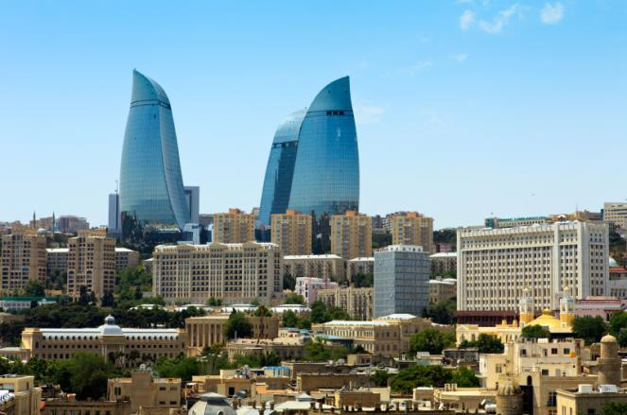www.tecis18.org; info@tecis18.org

Conference Sponsors:
International Federation of Automatic Control (IFAC) State Oil Company of Azerbaijan Republic (SOCAR) PASHA TRAVEL
Conference co-partners:
Azerbaijan Technical University Baku State University
Baku Engineering University Baku Higher Oil School
ADA University

Old City and Flame Towers

The city is the scientific, cultural and industrial center of Azerbaijan. Baku is rich on historical monuments as well as hypermodern buildings and lots of leisure activities for fair prices.

During the event technical and cultural visits will be scheduled, e.g. temple of fire, Heydar Aliyev Culture Centre, Old town
Contacts:

B.Ibrahimov ARAS, 52 Aliyar Aliyev str., AZ1072, Baku Phone: +994505744455
Email: aras.azerbaijan@gmail.com

P.Kopacek TU Wien, Favoritenstrasse 9, E325A6, 1040 Wien. Phone: +431 5880131800;Fax: +431 5880131899
Email: kopacek@ihrt.tuwien.ac.at

